U.S. Radiocommunication Sector
Fact Sheet
Working Party: ITU-R WP 7D | Document No: USWP7D_26Mar-doc04
Ref. Question ITU-R 260/7  Document 7D/235, Annex 11 | Date: 12/19/2025
Document Title: Updates to Working Document Towards a Preliminary Draft New Report: Radio Astronomy Facilities on the Moon RA.[SZM_FAC]
Author(s)/Contributors(s):  Sarah Marie Bruno, Villanova University  Jack O. Burns, University of Colorado  Chris De Pree, National Radio Astronomy Observatory (NRAO)  Tomas Gergely, independent consultant  Karen Masters, Haverford College | sbruno03@villanova.edu  jack.burns@colorado.edu  cdepree@nrao.edu  tegergely@gmail.com  klmasters@haverford.edu
Purpose/Objective: To provide information about planned projects to build radio astronomy facilities on the Moon.

Abstract: Following the adoption of the ITU-R Question 260/7 “Radio astronomy in the shielded zone of the Moon”, this new Report will summarize the currently planned projects/initiatives to build radio astronomy facilities on the Moon. This input contribution provides minor editorial updates to the document currently attached to the Chairman’s Report (7D/235 Annex 11). We propose to advocate for elevating this document to a preliminary draft new report at the upcoming meeting.

Radiocommunication Study Groups
Source: Document 7D/235, Annex 11 | Document 7D/XX  X March 2026
Source: Document 7D/235, Annex 11 | English only
United States of America
preliminary draft new REPORT [SZM_FAC]
Radio astronomy facilities on the Moon

Introduction
Following the adoption of the ITU-R Question 260/7 “Radio astronomy in the shielded zone of the Moon”, this new Report will summarize the currently planned projects/initiatives to build radio astronomy facilities on the Moon. This input contribution provides minor editorial updates to the document currently attached to the Chairman’s Report (7D/235 Annex 11). We propose to advocate for elevating this document to a preliminary draft new report at the upcoming meeting.

Attachment: 1

ATTACHMENT

PRELIMINARY
DRAFT NEW REPORT RA.[SZM_FAC]
Radio astronomy facilities on the Moon
(Question ITU-R 260/7)
(202X)
TABLE OF CONTENTS
Page
1 Introduction 4
2 Concepts and designs for lunar radio astronomy missions 6
2.1 Radio-wave Observations at the Lunar Surface of the photoElectron Sheath
(ROLSES) 6
2.2 Farside Array for Radio Science Investigation of the Dark ages and
Exoplanets (FARSIDE) 7
2.3 Lunar Crater Radio Telescope (LCRT) 7
2.4 FarView 7
2.5 Lunar Surface Electromagnetic Experiment (LuSEE) 8
2.6 TSUKUYOMI 8
3 Preferred locations for lunar radio astronomy 8
3.1 The Shielded Zone of the Moon 8
3.2 Lunar South Pole and other regions 9
3.3 Lunar Coordinate Systems and Reference Frames 9
4 Frequency usage by RAS and operational mission support in the lunar environment 10
4.1 Frequency bands used for science operations 10
4.2 Frequency bands used for operational mission support and data transfer rates 10
5 Summary 10
6 Related ITU-R Recommendations/Reports 10
7 Abbreviations/Glossary 10

1 Introduction
Radio astronomy is the study of naturally occurring radio emission of cosmic sources to understand the properties and evolution of astronomical objects and the universe. Measurement of the intensity of radio emission from cosmic sources provides information about the physical processes that dominate the formation and evolution of structures, from the largest scales to the smallest in the universe. Radio astronomy observations include both measurement of line intensities, which arise from quantum mechanical transitions of atoms and molecules, and of continuum emission, which arises from a variety of processes, including thermal and synchrotron radiation. Access to the full electromagnetic spectrum is important to probe these physical processes in both the local and distant universe.
As detailed in Recommendation ITU-R RA.479, however, much of the potential value of the electromagnetic spectrum for radio astronomy is unrealized due to its longstanding heavy use on Earth for other purposes and/or atmospheric attenuation. Scientific drivers to build radio telescopes on the shielded zone of the Moon therefore include the possibility to observe cosmic sources in radio frequency bands that are not accessible from Earth, either due to atmospheric absorption or due to human-made transmissions that overwhelm the faint natural emissions of cosmic sources. The shielded zone of the Moon, an area somewhat less than half of the lunar surface, is a zone in which passive observations remain unhindered by interference as this part of the Moon’s surface is always facing away from Earth and is therefore shielded from Earth-based and Earth-orbital radio signals. As such, it is crucial to protect this unique region for passive scientific research. Key technology developments for radio astronomy facilities to be built on the Moon include, e.g., broad bandwidth receivers to increase the radio telescope’s sensitivity for radio continuum observations.
The spectral lines of greatest interest to radio astronomy at frequencies below 275 GHz are listed in Table 1 of Recommendation ITU-R RA.314. These spectral lines occur at frequencies dictated by nature, but they may be observed at high redshifts within our own Galaxy or in external galaxies. Additionally listed in Table 1 of the same Recommendation are suggested minimum bandwidths that, in most cases, correspond to the widths of these lines, Doppler shifted within our own Galaxy. These minimum bandwidths are, however, not allocated or protected for radio astronomy uses on Earth in every instance. Further, many of the lines, of great astrophysical interest, can be observed at far lower frequencies, caused by the higher redshifts of external galaxies. One of the most prominent emission lines is the one that arises due to the spin flip of neutral hydrogen at a rest frequency of 1420.4058 MHz. Because hydrogen is ubiquitous in the universe, observations of this emission line provide the opportunity to probe the structure of the universe from the present day to the very distant past, including the epoch of reionization (EoR). However, due to the expansion of the universe, more distant cosmic radiation is redshifted relative to its rest-frame emission frequency (the redshift, z, is calculated as (f_{emit} – f_{obs})/f_{obs} where f__{emit} is the emitted frequency set by quantum physics, and f__{obs} is the observed frequency at the telescope). Thus, scientific observations of the neutral hydrogen line range from observations close to its rest frequency to below 65 MHz. Radio telescopes located in the Shielded Zone of the Moon (SZM) will be able to measure the faint radio emission of the neutral hydrogen line from the most distant cosmic sources without contamination from human-made emissions and thus provide the most robust measure of the evolution of structure in the universe.
Table 3 of Recommendation ITU-R RA.314 lists the frequency bands allocated to the radio astronomy service on Earth for continuum observations. Continuum emissions are those that cover a large range of frequencies and arise in the Universe through a number of emission mechanisms such as bremsstrahlung and synchrotron radiation. These emissions are also of great importance for astronomical observations. In many cases, particularly for bands under 70 GHz, the allocations are much narrower than would be desirable for the purposes of radio astronomy.
As designated in the Radio Regulations (RR), Article 22.22.1, the SZM is the surface area and adjacent volume of space that are shielded from emissions originating from within 100 000 kilometres of Earth’s centre. This geographic region is isolated both from Earth-based emissions and also from potential interference arising from satellites orbiting the Earth. As stated in Section V of Article 22:
22.22 1) In the shielded zone of the Moon emissions causing harmful interference to radio astronomy observations and to other users of passive services shall be prohibited in the entire frequency spectrum except in the following bands:
22.23 a) the frequency bands allocated to the space research service using active sensors;
22.24 b) the frequency bands allocated to the space operation service, the Earth exploration-satellite service using active sensors, and the radiolocation service using stations on spaceborne platforms, which are required for the support of space research, as well as for radiocommunications and space research transmissions within the lunar shielded zone.
22.25 2) In frequency bands in which emissions are not prohibited by Nos. 22.22 to 22.24, radio astronomy observations and passive space research in the shielded zone of the Moon may be protected from harmful interference by agreement between administrations concerned.
Articles 22.22 to 22.25 of the RR ensure that radio astronomy observations within the shielded zone of the Moon will be free from human-made interference throughout the majority of the radio spectrum. This unique resource will enable scientific discoveries that are not possible in the “radio loud” environment on Earth. This potential discovery space is especially favourable for detection of time-variable phenomena, where radio frequency interference (RFI) is particularly insidious, as RFI corrupts measurements that can never be re-acquired for these sources.
Recommendation ITU-R RA.479 provides guidance on the protection of frequencies for radioastronomical measurements in the shielded zone of the Moon. In particular, Recommendation ITU-R RA.479 recommends:
1 that, in planning the use of the radio spectrum, both nationally and internationally, account should be taken of the need to provide for radio astronomy observations in the SZM;
2 that, in taking account of such a need, special attention should be given to those frequency bands in which observations are difficult or impossible from the surface of the Earth;
3 that the frequency spectrum should be used in the SZM in keeping with the preliminary guidelines contained in Annex 1;
4 that special attention be paid to emissions into the SZM from deep-space platforms, satellites in the halo orbits near the Sun-Earth L₂ point, satellites in the Earth-trailing orbits, or transmitters near or on the Moon;
5 that in the frequency bands which would be considered for joint use by active and passive space stations in the SZM, radio astronomy observations should be protected from harmful interference. To this end appropriate discussions between concerned administrations may be conducted;
6 that in-situ radiocommunication equipment developed for the environment of Mars or other planets should not be deployed in the SZM, but the choice of frequencies for the close proximity link in the SZM should follow the preliminary guidelines contained in Annex 1.
Annex 1 of Recommendation ITU-R RA.479 includes an extensive discussion of frequency bands from 30 kHz to 1 THz. Annex 2 addresses frequency bands to be used for radiocommunications in the lunar environment proposed by Commissions 40 and 50 of the International Astronomical Union. As noted in these Annexes, all frequencies below 2 GHz in the SZM should be accessible to radio astronomy and frequency bands above this range should consider both spectral line and continuum observations. In other words, when considering frequency allocations in the lunar environment, it is critical to recognize the scientific importance of retaining a “radio quiet” environment within the SZM to ensure this unique resource remains accessible for scientific discovery.
In addition to scientific discovery, there are societal benefits to the development and construction of radio astronomy telescopes on the Moon. For example, the technology development required to build a radio telescope in such a remote location includes not only the materials for the physical structures, but also the development of communications and data transfer relays. In addition, as evidenced by prior astronomical projects, building a radio telescope on the Moon will engage the broader community in scientific endeavours, particularly since the results of such a project will address big picture questions that are relevant to all humanity.

2 Concepts and designs for lunar radio astronomy missions
In part to enable access to frequency ranges not observable with ground-based telescopes on Earth, many of the initial concepts and designs for radio astronomy facilities to be built on the Moon are for low frequency radio telescopes. These early missions take advantage of the fact that low frequency observations typically do not require high precision telescope surfaces. However, it is anticipated that the next generation of radio telescopes on the Moon will operate in higher frequency bands as well. High frequency observations will be of great scientific importance for future missions.

2.1 Radio-wave Observations at the Lunar Surface of the photoElectron Sheath (ROLSES)
As a first step toward measuring radio-wave propagation effects on the lunar surface, ROLSES consists of a low-frequency radio spectrometer operating from 2 kHz to 30 MHz using antennas at 1 m and 3 m above the surface landed on the Moon as part of NASA’s Commercial Lunar Payload Serviced (CLPS) program. ROLSES was designed to measure the photoelectron sheath density values during the lunar day. These values are expected to vary based on height and solar wind parameters. ROLSES’s goals also included measurements of reflection of incoming radio emission from the lunar surface, monitoring of radio frequency interference, detection of lunar dust impacts, and measurements of the Galactic radio spectrum from 1-30 MHz. ROLSES launched as part of the Intuitive Machines 1 (TO2-IM) mission on February 15, 2024 and landed on the rim of the Malapert A crater near the south pole on February 22, 2024. Data were collected from the ROLSES spectrometer both in transit to the Moon and over several days on the lunar surface despite the unfortunate tilt on the lander. Results have been published. An upgraded ROLSES-2 instrument is scheduled to launch on another CLPS lander to the lunar near side in 2026. Link: https://www.colorado.edu/ness/projects/radiowave-observations-lunar-surface-photoelectron-sheath-rolses)

2.2 Farside Array for Radio Science Investigation of the Dark ages and Exoplanets (FARSIDE)
A concept currently under development within the United States, the notional concept for FARSIDE (see https://www.colorado.edu/project/lunar-farside/sites/default/files/attached-files/farside_finalrpt-2019-nov8.pdf) consists of a low frequency interferometric array of 128 dipole antennas deployed across a 10 km area. With a planned frequency range of 100 kHz to 40 MHz, FARSIDE will enable observations extending well below frequency bands accessible on Earth. In particular, the lunar environment allows sky noise limited observations at sub-MHz frequencies, since it is not subject to auroral kilometric radiation or to plasma noise from the solar wind. Observations in this frequency range will enable a variety of science programs including monitoring of the nearest stellar systems and measuring the neutral hydrogen line redshifted to z~50-100.
The technical characteristics of FARSIDE are still under development. One rendition includes:
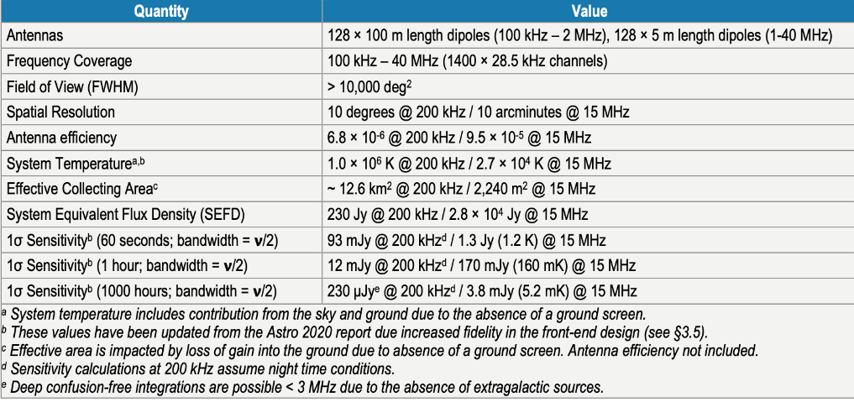
In this design, FARSIDE will have a central base station with 128 antenna pairs distributed along four independent spiral spokes. This distribution is designed to improve imaging performance while simultaneously minimizing rover travel on the lunar surface during deployment. Tethers between the base station and the antenna nodes provides power, signal processing, and telecommunications (via a relay) back to Earth. (https://www.colorado.edu/project/lunar-farside/)

2.3 Lunar Crater Radio Telescope (LCRT)
A concept under development is to deploy a wire-mesh parabolic surface in an existing lunar crater to create an extremely large filled aperture radio telescope. The LCRT will observe low frequency bands that are blocked by Earth’s ionosphere (6-30 MHz). To be sensitive to these long wavelengths, the LCRT will be built within a crater over 3 kilometres wide. The LCRT is similar in concept, but vastly larger, than the Arecibo 305 m and FAST telescopes built on Earth. The receiver is suspended by cables over a surface that will be entirely reflective to radio waves.

2.4 FarView
A concept under development via the NASA Innovative Advanced Concepts (NIAC) program, known as FarView, plans to deploy 100,000 low frequency dipole antennas over 200 km². As described at https://www.nasa.gov/directorates/spacetech/niac/2023/FarView_Observatory/, the low frequency (5-40 MHz) antennas will be manufactured in situ by first extracting metals from the lunar regolith. The science goal is to measure the power spectrum of the first structures formed during the Dark Ages of the early Universe, thereby testing the fundamental models of physics and cosmology in a new epoch.

2.5 Lunar Surface Electromagnetic Experiment (LuSEE)
The LuSEE mission consists of two main components: the “Night” mission and the “Lite” mission on two separate CLPS landers to the lunar far side. “Night” will focus on low frequency (below 50 MHz) radio astronomy and deploy and operate largely autonomously (standalone operations). The “Lite” mission will carry out research into the lunar ionosphere, surface plasma physics and waves, DC electrostatic potentials, and dust impacts.
LuSEE Night will deploy autonomously and consist of four 3-meter antennas in a cross-dipole configuration. This assembly will be on a rotating turntable, and the attached receivers and spectrometer will send data back to the Earth via the Lunar Path finder satellite developed with funding from ESA. A radio beacon will also be deployed in lunar orbit to measure the LuSEE-Night radio beam. LuSEE-Night is scheduled to launch in 2025/26.
Relationship to the Shielded Zone of the Moon (No. 22.22-22.25)
The LuSEE Night mission, in particular, will make use of the radio-quiet conditions in the far side (Shielded Zone) of the Moon, as well as the ability for low-frequency radio waves to pass to the surface of the Moon relatively unhindered. On Earth, by contrast, such frequencies may be impacted by the ionosphere as well as other transmitted signals.
Astronomical signals in frequencies below 50 MHz will be particularly useful for cosmological studies of the early universe, including signals shifted to lower frequencies by the expansion of the universe, originally emitted by neutral hydrogen at 1420.406 MHz.

2.6 TSUKUYOMI
TSUKUYOMI is a low-frequency radio astronomy observation facility currently under conceptual study in Japan. TSUKUYOMI consists of several self-supporting telescope antenna units. One unit contains a deployable dipole antenna, a signal processing system, and power supply and communication systems. The anticipated observing frequency range is 1-50 MHz, which is difficult to observe on Earth because of Earth’s ionosphere and radio interference from artificial sources. In the first phase of construction in late 2020s, one unit will be installed on the lunar surface to study solar and Jupiter’s radio burst. It also aims to pursue the science of the Moon and will make measurements to understand the electromagnetic environment of the lunar surface, including the nature of the lunar ionosphere and floating charged dust. For full-scale observations in 2030s, multiple units will be installed in the shielded zone of the Moon to function as a radio interferometer. The major objectives of TSUKUYOMI include the study of the very early universe before the formation of the first stars, i.e. “the Dark Ages”, and study of the environment of giant exoplanets through their auroras and radio-wave bursts of central stars.

3 Preferred locations for lunar radio astronomy

3.1 The Shielded Zone of the Moon
The Shielded Zone of the Moon comprises the surface area and adjacent volume of space that are shielded from emissions originating from within 100 000 kilometres of Earth’s centre. This region is protected from Earth-based radio frequency interference and also from Earth’s auroral kilometric radiation, which is a significant source of natural radio emission below 500 kHz.
Specific landing sites need to take into consideration radio wave propagation characteristics in the lunar environment. In particular, low frequency radio waves can be diffracted around the Moon’s limb, resulting in variations in the RFI environment based on location and the frequency bands under consideration. An example of the RFI suppression expected at 100 kHz is shown in Figure 1. At higher frequencies, above 10 MHz, for example, the RFI suppression is more than -90 dB within a few degrees of the limb. To reduce the potential for radio frequency interference, sites under consideration for the majority of low frequency projects currently under development are located within the region with highest expected RFI suppression, as indicated in Figure 1.
Figure 1
Map of RFI suppression at 100 kHz based on numerical simulations
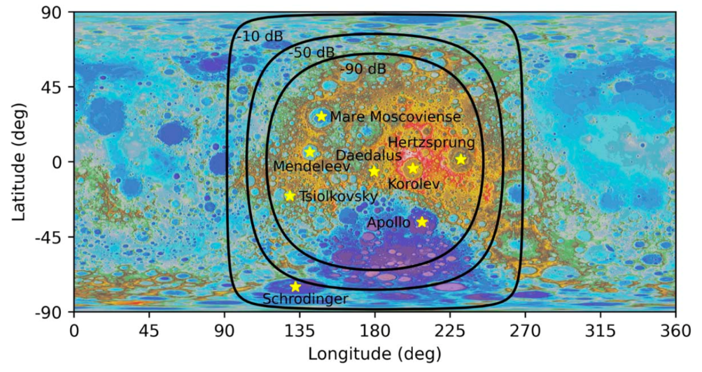
Contours indicate suppression of −10, −50, and −90 dB relative to the incident intensity. Map colors indicate elevation. Potential landing sites are indicated by yellow stars. Adapted from Burns et al. 2021, The Planetary Science Journal, volume 2, page 44. https://doi.org/10.3847/PSJ/abdfc3.
Further discussions of site selection for radio astronomy within the SZM can be found in Le Conte et al. 2023, RAS Techniques and Instruments, Volume 2, Issue 1, pages 360-377. https://doi.org/10.1093/rasti/rzad022 as well as in Polidan et al. 2024, Advances in Space Research, Volume 74, Issue 1, pages 528-546. https://doi.org/10.1016/j.asr.2024.04.008.

3.2 Lunar South Pole and other regions
The lunar south pole is also a preferred location for radio astronomy facilities, with significant shielding from radio frequency interference at frequencies above 10 MHz. Specifically, the South Pole Aitken Basin (the large low-elevation purple region in Figure 1) is a potential location for higher frequency radio astronomy facilities.

3.3 Lunar Coordinate Systems and Reference Frames
A coordinate system is needed for specifying precise locations preferred for constructing radio astronomy facilities on the lunar surface. The Selenographic Coordinate System may be useful for this purpose, Also, the United States’ 2022 National Cislunar Science & Technology Strategy report cites a need for a cislunar reference frame tied to the celestial reference frame and terrestrial reference frame; see page 13 of the report linked here: https://www.space.commerce.gov/white-house-releases-national-cislunar-st-strategy/.

4 Frequency usage by RAS and operational mission support in the lunar environment

4.1 Frequency bands used for science operations
For practical and scientific reasons, the majority of current mission plans and concepts are for radio telescopes operating at low frequencies, between 10 kHz and 110 MHz. These pathfinder missions will reveal the capability and challenges of building and operating radio astronomy facilities in the lunar environment. As noted in Recommendation ITU-R RA.479, future radio astronomy facilities are envisioned that will target frequency bands that are not accessible from Earth, either due to atmospheric absorption or human-made interference. Future mission concepts may observe in a wide range of frequencies from 10 kHz to 3 THz to access various frequency bands not accessible from Earth.

4.2 Frequency bands used for operational mission support and data transfer rates
Radio astronomy facilities on the Moon will require operational support, including telescope control and data transfer. For this purpose, bands are allocated to the space research service, space operation service, the Earth exploration-satellite service using active sensors, and the radiolocation service using stations on spaceborne platforms (as stated in RR No. 22.24). In particular, frequency ranges that are not accessible on Earth, due to natural causes, such as the Earth’s ionosphere and atmosphere, or due to human transmissions, should be avoided for lunar communications.

5 Summary
Radio astronomy facilities on the Moon represent a transformative opportunity for astronomical research, leveraging the unique advantages of the lunar environment. The SZM offers a pristine environment free from Earth-based radio signals and atmospheric noise, enabling unprecedented sensitivity for observing radio waves across a broad spectrum. A number of facilities and mission concepts have been proposed including the Radio-wave Observations at the Lunar Surface of the photoElectron Sheath (ROLSES), which already landed and collected data in 2024, among other projects already in development. Lunar-based radio astronomy holds immense potential to address fundamental questions about the universe. As stated in RR No. 22.22-22.25, in frequency bands in which emissions are not prohibited, concerned administrations should seek agreement to ensure protection of radio astronomy observations and passive space research in the SZM. The level of harmful interference is determined by agreement between the administrations concerned, with the guidance of the relevant ITU-R Recommendations.

6 Related ITU-R Recommendations/Reports
Recommendation ITU-R RA.314 – Preferred frequency bands for radio astronomical measurements
Recommendation ITU-R RA.479 – Protection of frequencies for radioastronomical measurements in the shielded zone of the Moon

7 Abbreviations/Glossary
DAPPER Dark Ages Polarimeter PathfindER
EoR Epoch of Reionization
FARSIDE Farside Array for Radio Science Investigation of the Dark ages and Exoplanets
LCRT Lunar Crater Radio Telescope
LuSEE Lunar Surface Electromagnetic Experiment
RFI Radio Frequency Interference
ROLSES Radio-wave Observations at the Lunar Surface of the photoElectron Sheath
RR Radio Regulations
SZM Shielded Zone of the Moon

Note that the ITU designation for low frequency (LF) is the range 30-300 kHz. In this document, however, the term “low frequency” is rather used to denote frequencies on the low end of radio astronomy observations (10 kHz to 110 MHz).
Hibbard, Joshua, Burns, Jack, et al. “Results from NASA’s First Radio Telescope on the Moon: Terrestrial Technosignatures and the Low-Frequency Galactic Background Observed by ROLSES-1 Onboard the Odysseus Lander.” March 18, 2025. https://arxiv.org/pdf/2503.09842

